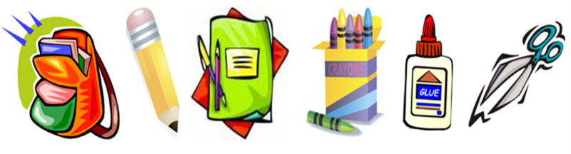 Moss Park Elementary

Second Grade Supply List

2015-2016

* 2 boxes of Crayola crayons 16-24 count
* 1 box of Crayola colored pencils
* 1 pair of scissors (Fiskar) (can be reused from previous year)
* 3 (24) packs of pencils (PLEASE SHARPEN!!)
* 24 cap erasers
* 1 zippered cloth pencil bag or small pencil box
* 1 package of copy paper: 8 ½ x 11
* 1 pack of Expo markers
* 5 pocket folders with PRONGS (blue, green, purple, red, & yellow)
* 1 six pack of glue sticks
* 1 bottle of Elmer’s glue
* 4 spiral notebooks, wide ruled
* 1 (1 inch) 3 ring binder, white with clear view front pocket
* 1 large box of tissues
* 1 pack of wide ruled notebook paper
* Student headphones (can be reused from previous year)
* 1 container of Lysol wipes
* 1 bottle of hand sanitizer

**Boys only** **Girls only**

* 1 large bottle of antibacterial hand soap ---1 container of baby wipes
* 1 (4 pack) of highlighters ---1 box of Band-Aids
* 1 box of gallon sized Ziploc bags ---1 box of quart sized Ziploc bags
* 1 pack of 8” plates, white ---1 pack of small plates, white
* 1 pack of Crayola markers ---2 Expo erasers